Networking for Software Developers

In this lab we will build a simple graphical application that is responsive and that uses basic widgets and demonstrates event handling. The screen shot below the expected result. Please examine the rubrics in building your GUI. Notice the widgets are not place directly on the form but on a frame with width, padding and relief.

You must not use any other library except tkinter. Your code must run on a standard machine.

Your code must be written as a class that inherits from Tk and the application must resize gracefully.

The apps must start in a usable state i.e. all the relevant values of the input widget must be set. So if you click ok when the app starts, then you should get the pop-up message shown in the last page.

The reset button must set the app to the initial start state.

## Due:

See assessment folder.

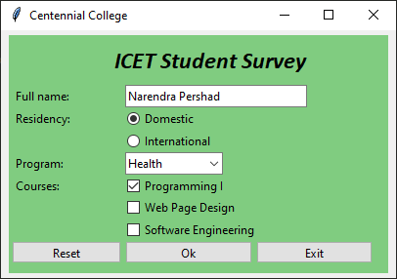

Widget must align vertically as well as horizontally with their matching widget.

## Rubrics:

|  |  |
| --- | --- |
| Marks | Task description |
| -50 | * Application not designed as a class. * Application not responsive: The widget does not move when the main window is resized. * Application starts with missing input values. All the fields must be already filled out. * Displaying a None value in your pop-up window. |
| 2 | Frame  Container for all of the widget. |
| 2 | Label for the name of the data-entry form |
| 4 | First column with the following labels:  Full name  Residency  Program  Courses  Color and font can be anything of your choice but must be pleasing to the user. |
| 3 | Entry that captures the username. |
| 6 | Radiobuttons: |
|  | Domestic with value **dom**  International with value **intl** |
| 5 | Combobox with minimum four items |
|  | AI, Gaming, Health, Software |
| 5 | Minimum three Checkboxes |
|  | Programming I with onvalue **COMP100** and offvalue '' Web Page Design with onvalue **COMP213** and offvalue '' Software Engineering with onvalue **COMP120** and offvalue '' |
| 2 | **Reset**  Resets/initialize the values in the form by calling the function at the end of this table |
| 2 | **Ok**  Calls a function that is describe at the last but one of this table |
| 3 | **Exit**  Terminates the application |
| 7 | **Function**  Create and shows a messagebox with the information from the form as shown in the screenshot below.  This function is called by the Ok button |
| 6 | **Function**  Sets the form to a usable state. See the diagram above.  This function is called by the Reset button.  Can also be called in the constructor of the app. |
| 2 | **Resizing**  Position and size must adjust as the app window size changes. |
| 2 | **Aesthetics**  Must look pleasing to the user. |
| 50 |  |

# The pop-up window

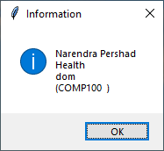

### Hints

You are asked to build the gui application shown below. You are advised to examine the screenshot and plan your task accordingly

Use the following url to get coding hints and guidelines:

https://likegeeks.com/python-gui-examples-tkinter-tutorial/

https://docs.python.org/3/library/tkinter.ttk.html

https://www.tutorialspoint.com/python/python_gui_programming.htm

#### Required features/functionalities:

1. Should look as close to the image above as possible.
2. The widget must function as they would normally do.
3. The Reset button must reset all the widgets to its original state.
4. The Exit button must terminate the application.
5. When the Ok button is clicked the following pop-up window is displayed

#### Submission

1. Your code file will be named «your_first_name».py
2. Must be uploaded to course dropbox